Springchallenge december 2020 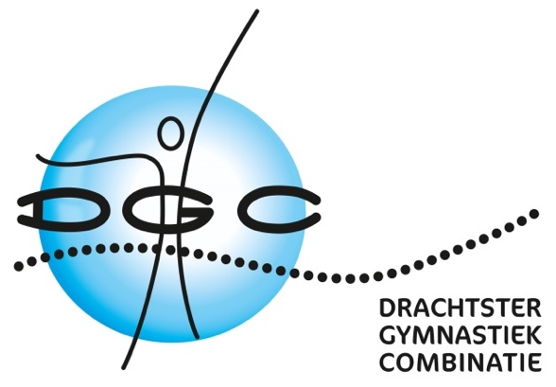

JE-DGCA-team1 Indy,Annique,Emsé, Tiara
JE-DGCA-team2 Eline, Tamar, Esmee, Senna
JE-DGCA-team3 Sinne, Dewy, Naomi, Myrthe
JE-DGCA-team4 Senna, Martje, Tiara, Eline
JE-DGCA-team5 Louïse, Sterre, Jasmijn, Fenna
JE-DGCA-team6 Demi, Evi, Fayenn, Iris
JE-DGCA-team7 Amber, Lieke, Lotte, Nynke
JE-DGCA-team8 Marise, Misa, Jasmijn, Louïse
JE-DGCA-team9 Anouk, Lina, Fardau, Nina
JE-DGCA-team10 Rihanna, Sajenna, Jael, Chelena

JU-DGCA-team1 Sofie, Amarens, Ynskje, Jasmijn
JU-DGCA-team2 Nejla, Ryanna, Aimee, Esra
JU-DGCA-team3 Noa, Julia, Ivye, Sanne
JU-DGCA-team4 Sylke, Fleur, Shanaya, Amber

SE-DGCA-team1 Yentl, Danielle, Yael, Dian
SE-DGCA-team2 Sharon, Chantal, Myrthe, Linda

